Focused program review
Academic Division Policy
In the event a school, department or program 1) suffers a precipitous enrollment drop, 2) fails to meet accepted academic standards, or 3) fails to meet financial performance expectations, a focused program review may be called by the President, the Academic Vice President (AVP) or the University Advisory Council (UAC). A focused program review may be called absent a declaration of an enrollment emergency.
This formal focused program review is conducted by an ad hoc task force.

Critical triggers
- Financial performance of an academic program below projection for one or more years
- Negative trends or poor outcomes in key educational quality performance indicators
- Negative trends in employer satisfaction with program graduates
- Negative trends in key performance indicators from alumni or currently enrolled students

Criteria for declaration of enrollment emergency
- Substantial decline of enrollment that potentially jeopardizes a program’s quality, stability, or fiscal well-being, and would likely substantially affect the University as a whole
- Evidence that current funding levels for faculty may have to be modified

Procedure
An ad hoc Task Force for Focused Program Review is established, consisting of two subcommittees: Academic and Budget. The Academic Subcommittee addresses issues relating to enrollment, quality, outcomes and performance. The Budget Committee addresses issues relating to finance. A two-part report written by each subcommittee is submitted to the President and the University Advisory Council (UAC). See flowchart on next page for possible next steps.

Implement action plan evaluation cycles reports
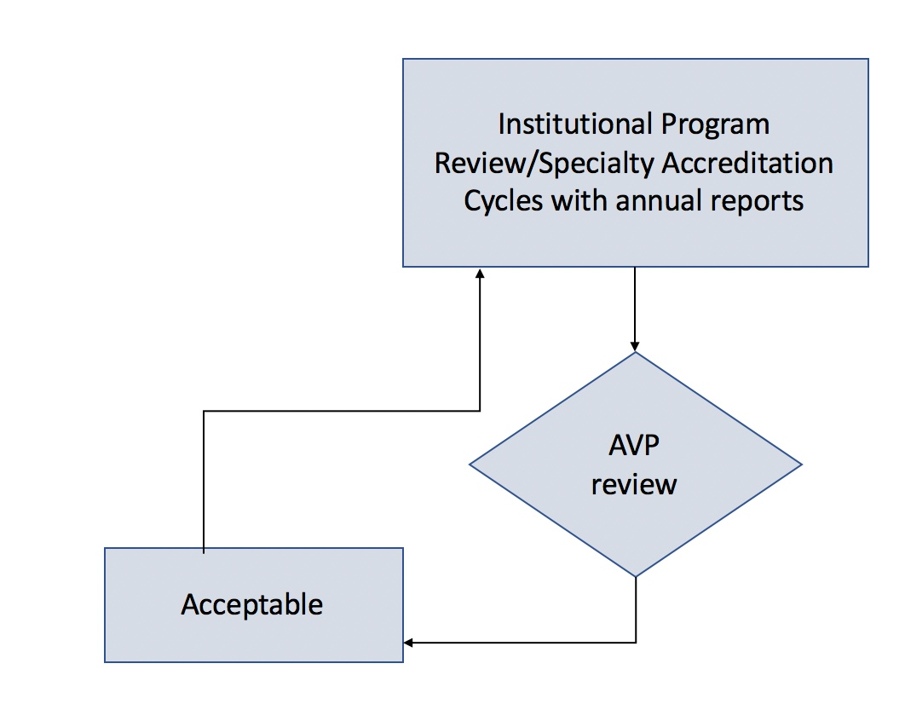
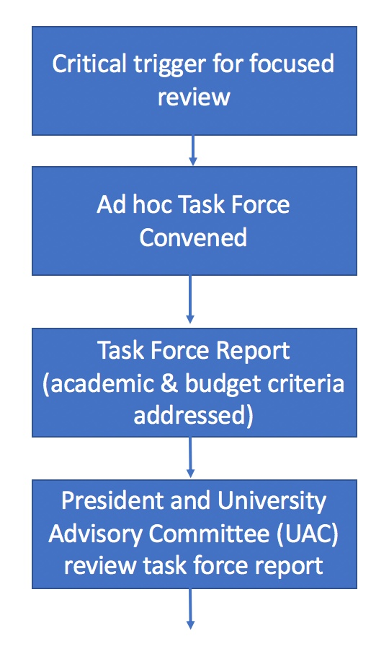
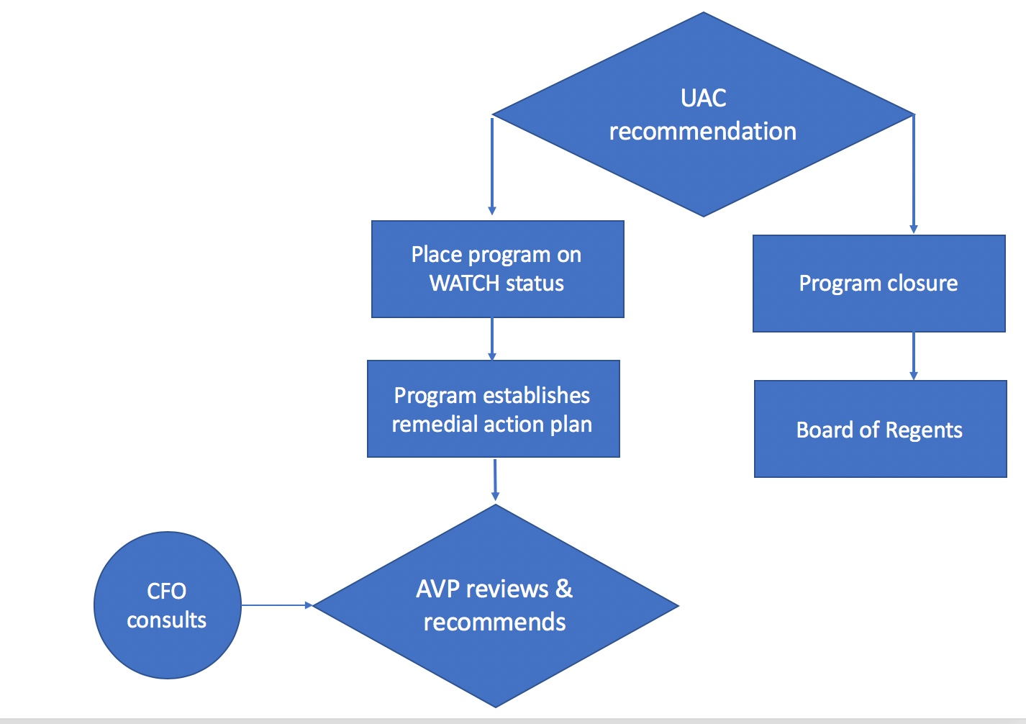

Academic Subcommittee

Membership

- Academic Vice President (Chair)
- Chair, University Curriculum Committee
- President, Faculty Organization (FO)
- 2 faculty (both internal & external to program in review), named by AVP in consultation with FO leadership

Report components
- Clear problem statement (may require formal market analysis)
- Analysis of why program has been unsuccessful in meeting performance targets
- Recommended corrective actions
- Retrenchment plan (with financial impact analysis) that allows the program to meet budget requirements for no less than 3 years

Budget Subcommittee

Membership
- Vice President, Finance & Administration (Chair)
- Representative, Enrollment and Student Services
- Program Chair or Director
- Budget Manager

Report components
- Budgetary analysis of program profit and loss projected for the current year and 2 subsequent years, based on trends
- Analysis of program’s financial situation on the University as a whole including impact on University’s ability to achieve strategic initiatives
- Statement that details what is reasonable to expect in terms of increases in student enrollment, given national trends and competitive position of the program

Essential criteria to release WATCH status
- Enrollment targets are met as described (in task force report) within 2 – 3 years
- Revenue to cover program expenses and required overhead is sufficient such that the University budget is not unduly compromised. Annual budget reviews are required in year 2 and 3
- Program can meet or exceed all specialty accreditation requirements
- Graduate performance on licensure and/or certification examinations is acceptable
- Number and quality of faculty are appropriate to conduct the curriculum
- A comprehensive curriculum evaluation has been conducted and the program can demonstrate quality and cost effectiveness
- Other requirements for remediation, as required by the Academic Vice President, are met

SMU Faculty Handbook (12/2017 revision) pp. 17 – 20. This handout contains key excerpts of the full policy.

