SYLLABOT INSTRUCTIONS

SyllaBot saves you time in creating your course syllabus and helps ensure an accurate syllabus.

How does it work?
The SyllaBot app collects the latest information from official SMU sources and uses it to automatically generate a draft syllabus Word document that you can easily edit. The majority of faculty using SyllaBot say it saves them time and makes creating their syllabi easier.

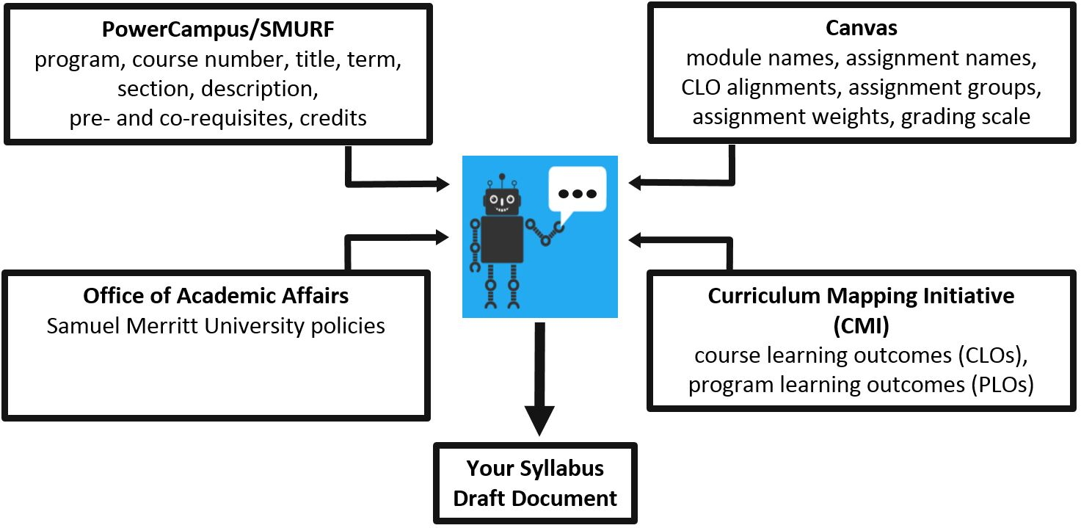

Prepare your Canvas course to get the most from SyllaBot
- Add each assignment to a module on the Modules page in Canvas.
- If you want the CLOs aligned with your assignments to appear on your syllabus, be sure to align your assignments with the CLOs using a Canvas rubric.

SyllaBot is updated daily. If you make changes to your Canvas course (modules, assignments, assignment groups, weights, or CLO alignments), your SyllaBot draft syllabus won’t reflect those changes until the following day.

Edit the SyllaBot draft syllabus
- After preparing your Canvas course, download a draft syllabus Word document by clicking the SyllaBot link on the Syllabus page in Canvas.
- Save and retitle the draft syllabus.
- Edit the draft syllabus. Or if you prefer, you can copy and paste the up-to-date information from the draft syllabus into your existing syllabus document.

For help using SyllaBot, email either A&II or Valerie Landau, Associate Director of the Center for Innovation and Excellence in Learning.

