Step by step instructions when creating a check request in Onbase-workflow

Click on this link to create a check request
http://onbasebdi.sutterhealth.org/OnBaseBDIPRDWeb15/Workflow/WFLogin.aspx?LifeCycleID=120&QueueID=193

*If there is a new vendor that needs to be added into Lawson, please provide a w9 for that vendor. If the vendor would also like payment to be setup as ACH, please fill out the ACH form along with the w9. Attach a void check or bank financial document that shows the vendor information, account number and routing number. Reminder, don’t forget to sign and date all documents.

*Pre-approval on an email or document is accepted. No wet signature is accepted. The email or document has to contain information about the invoice and payment amount, for auditing purposes. The coding has to be filled out. If everything is all there, we can push the check request out as Pre-Approved.

Step 1
Click on the plus sign that is next to 'AP01 – Processing.'

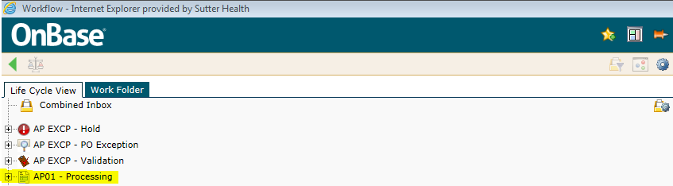

Step 2
Click on the yellow folder that says 'Check Requests.'

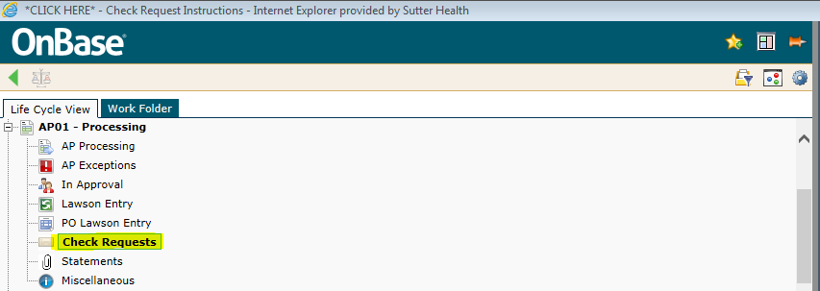

Step 3
Please read the message below to see if submitting a check request is the correct route for your request.

If you choose to proceed with submitting a check request then you will need to:
Enter your Sutter Health User ID, if it did not auto populated already and hit the button 'Save.'

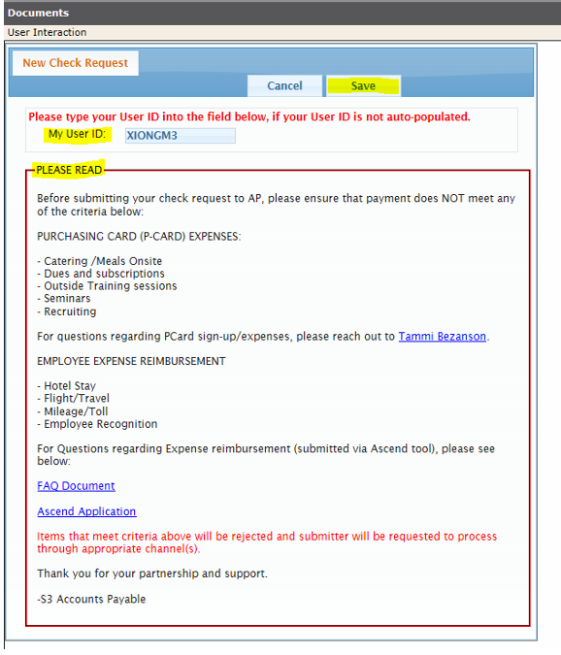
Step 4
Please read the 'AP Check Request Instructions' then click on the button 'Create Check Request.'

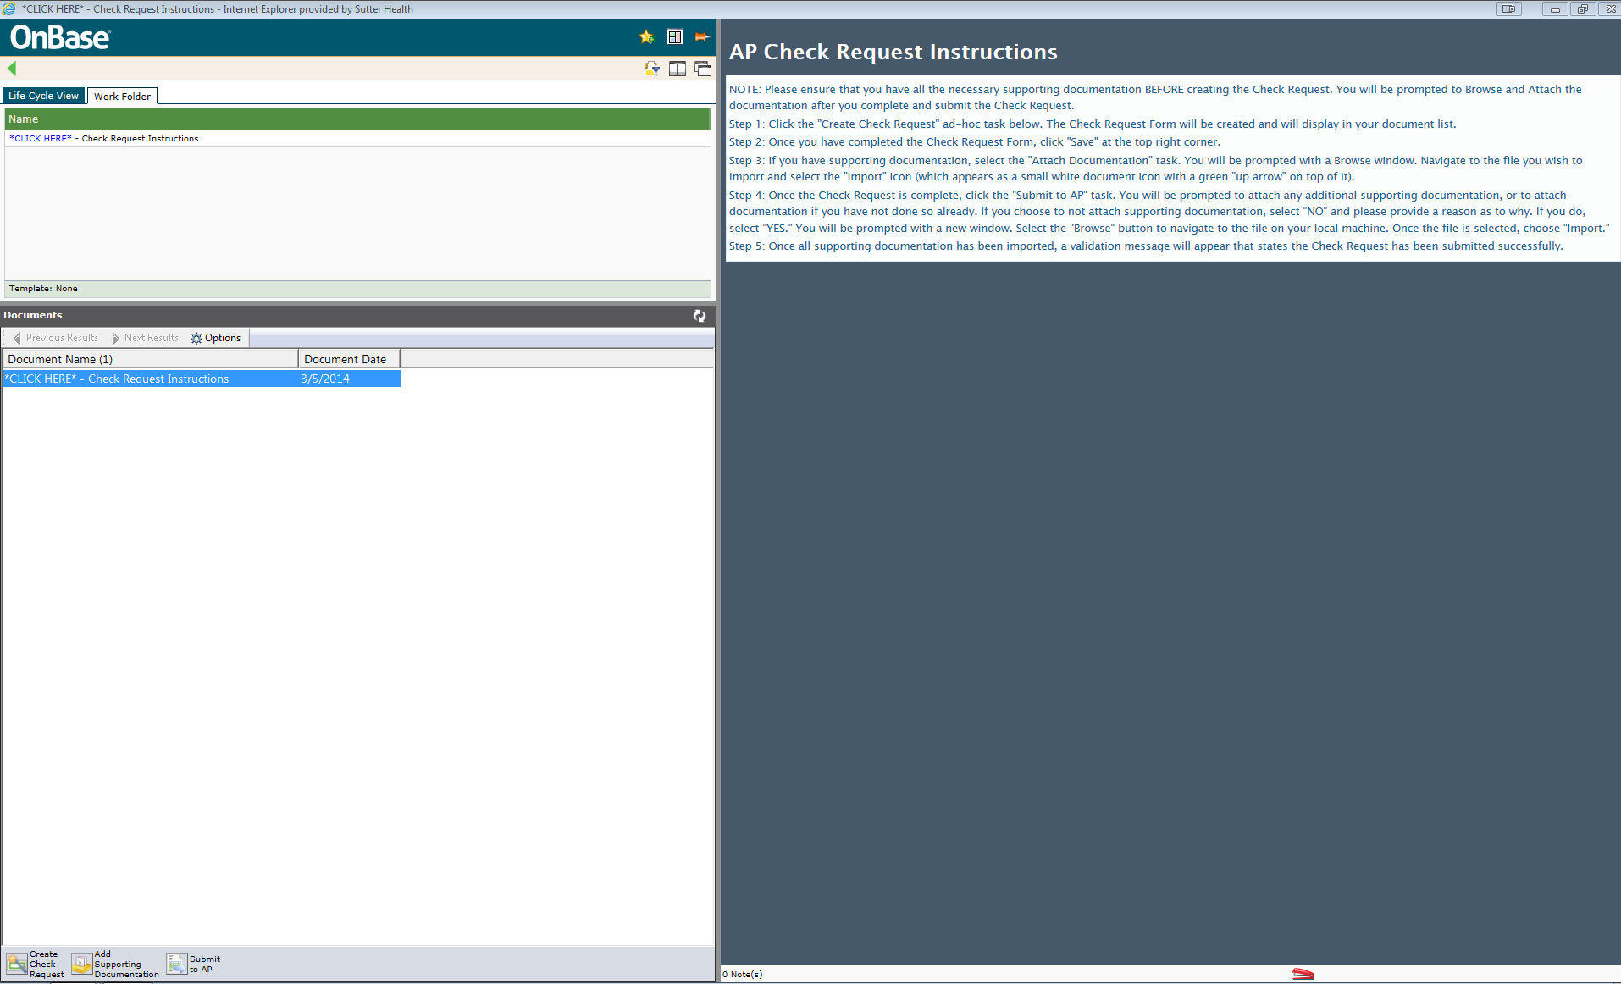
Step 5
To start your check request, please click on 'CLICK HERE" - To View Check Request From,' document date: today's date.

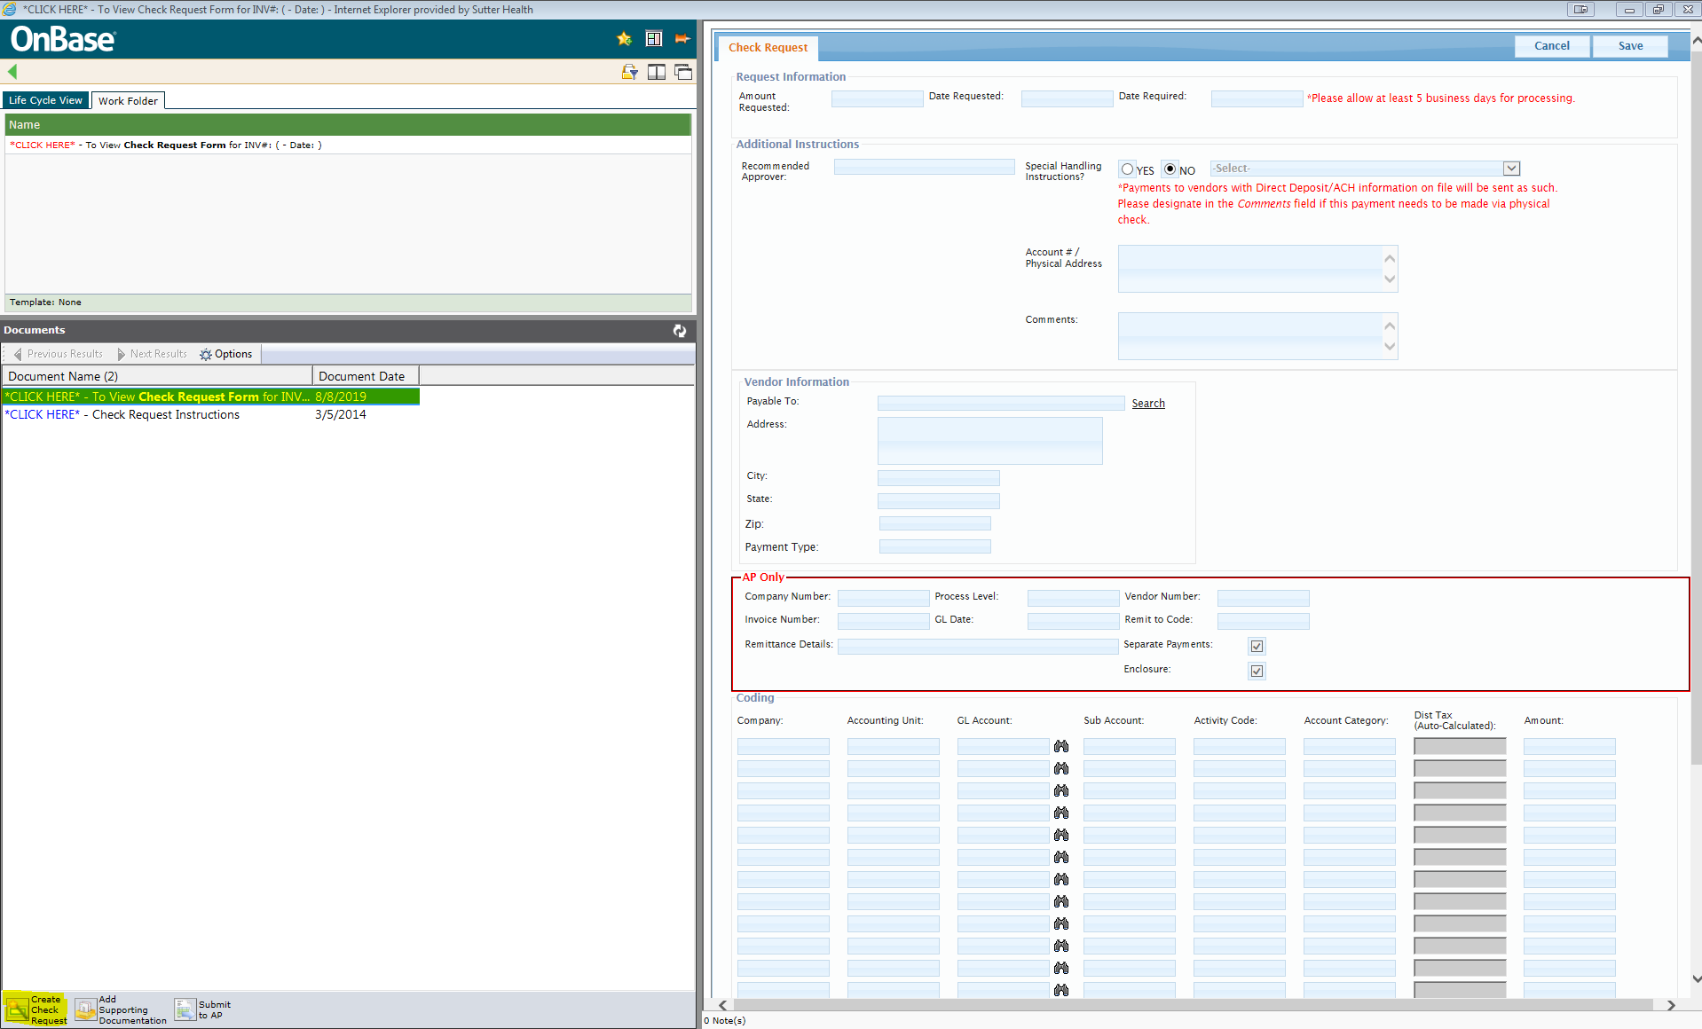
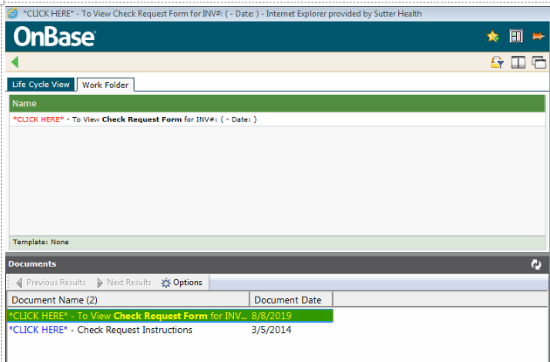

Step 6 Fill out the following information.

Amount Requested needs to match the GL Total amount. Please see the coding section for the GL Total amount.

Date Requested is today's date.

Date Required.

Recommended approver: Please put the approver's first and last name.
Sometimes the sutter id name is enter here, we have to take the extra step to look up their first and last name.

Special Handling: If no special handling is needed, leave it as ‘no.’ Your payment will go out via the payment type set up for this vendor.
If special handling is needed, please see my screen print below for a detail explaining of how to use or when to use a specific special handling.

Physical address means an actual address, no po box address.

Physical address format recommended incase of a return check.
Fedex account number is any, or cost center number
Sutter facility name or vendor name
Attention to person is any
Full address

Example:
Fedex acct# 123456 or Cost center# 123456
Sutter Shared Services
Attention or Attn: Maryann Xiong
9100 Foothills Blvd
Roseville CA 95661

'Comments field' is optional for special instructions such as: please write the invoice number or account number on the check, or any other special instructions you wish to put. There is a max or limit of 15 characters only.

For the Vendor information,
You can use the search button to look for the vendor number if this vendor exist in our system, if not, then enter the vendor information. The check will be made out to this vendor.

Fill out the coding and hit the 'Save' button.

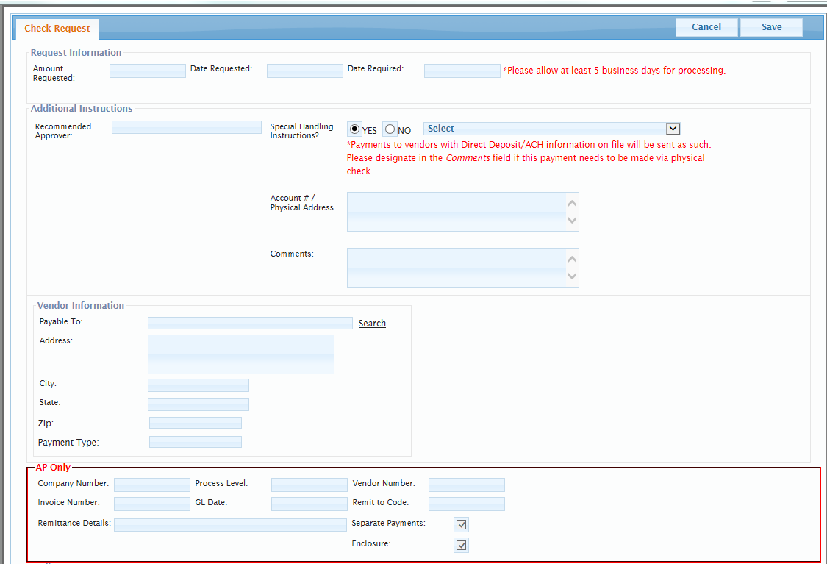

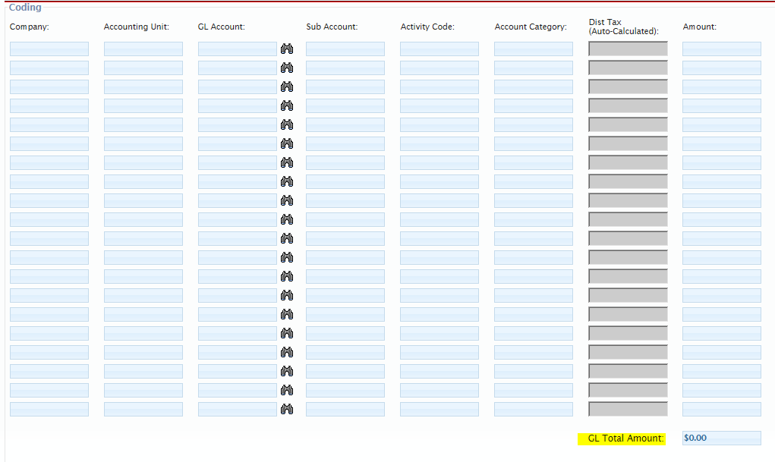

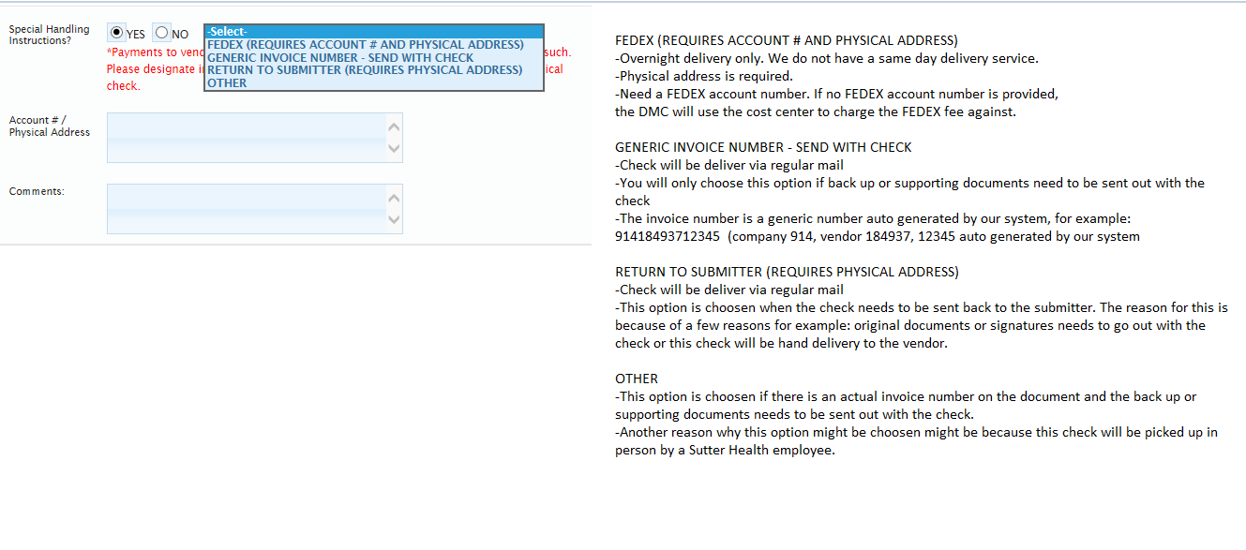

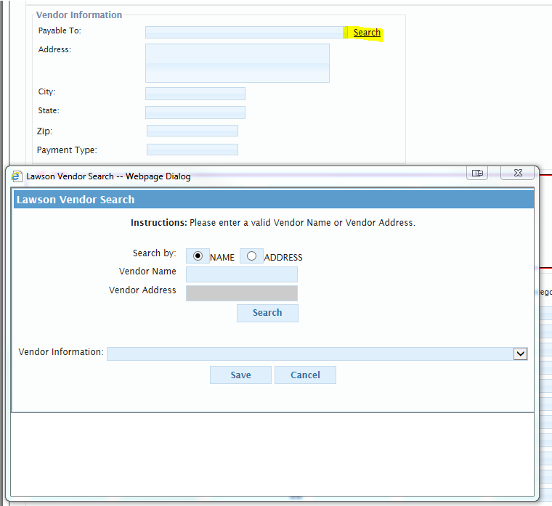
Step 7
Supporting documents are required for auditing purposing. We need supporting documents to support the payment amount requested.

To attach supporting documents, please click on the icon 'Add Supporting Documentation.'
Hit 'Browse' to attach then hit the icon with the white paper and green arrow to upload your document.

*If you need to attach more than 1 document, then repeat the steps again: Clicking on icon 'Add Supporting Documentation,'
Hit 'Browse, ' then hit the icon with the white paper and green arrow to upload your document.

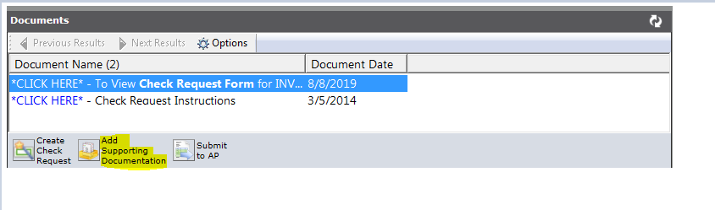

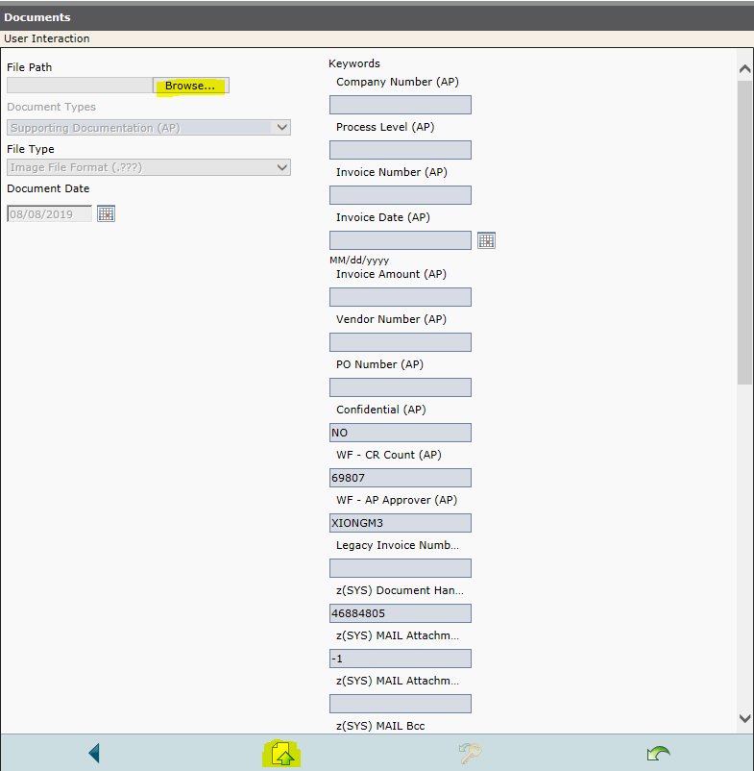
Step 8
If you are done filling out all the information for the check request and added all the supporting documents you need,

Hit the 'Save' button,

Then send this check request off by hitting the button 'Submit to AP.'

