How to print an enrollment or degree verification

Click on “mySMU Login” on the main SMU webpage:

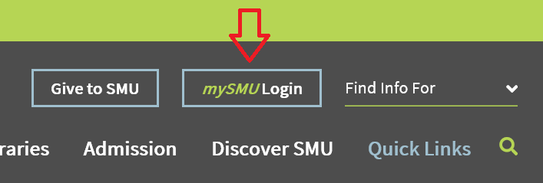

Login using your SMU username and password

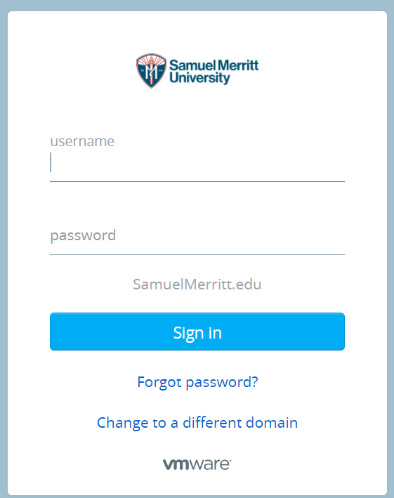

Choose the “NSC Enroll Verify” icon:

